MARMARA UNIVERSITY
FACULTY OF ENGINEERING
COMPUTER ENGINEERING

PHYS1104
PHYSICS LABORATORY
EXPERIMENT 7
Magnetic Field of Solenoids
SXGXE7

NAME | STUDENT NUMBER

Submitted to: Hüseyin YALTIRIK
1-) PURPOSE
This experiment will give us an idea about magnetic flux density along the axis of a solenoid with the Hall probe the magnetic permeability of the air.
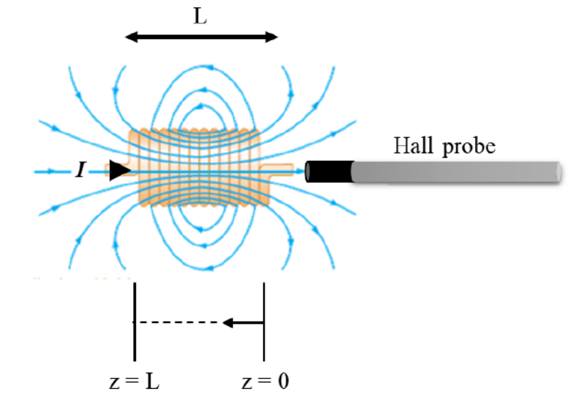
2-) CALCULATIONS & RESULTS
$$μ_{0}=1.26⋅{10}^{-6}m⋅\frac{T}{A}(Theoretical)$$
$$μ_{0}=\frac{B⋅L}{N⋅I}(Experimental)$$
 | Magnetic Field Values Due to Center of Length of The Solenoid |  |  |  |  |  |  |  |  |  |  |  | B vs I
N (turns) | 100 |  |  |  | 200 |  |  |  | 300 |  |  |  | 300
R (Ω) | 1,5 |  |  |  | 3 |  |  |  | 3,7 |  |  |  | 3,7
L (cm) | 4,3 |  |  |  | 9 |  |  |  | 14,3 |  |  |  | 14,3
D (cm) | 4,2 |  |  |  | 4,2 |  |  |  | 3,5 |  |  |  | 3,5
 |  | B (mT) | B (mT) |  |  | B (mT) | B (mT) |  |  | B (mT) | B (mT)
 | Max | 1,100 | 2,300 |  | Max | 1,500 | 2,800 |  | Max | 1,300 | 2,800
 | Z (cm) | 0,5 A | 1,0 A |  | Z (cm) | 0,5 A | 1,0 A |  | Z (cm) | 0,5 A | 1,0 A |  | I (A) | B (mT)
 | -5,5 | 0,000 | 0,000 |  | -9,0 | 0,000 | 0,000 |  | -10,5 | 0,000 | 0,000 |  | 0,000 | 0,000
 | -5,0 | 0,000 | 0,200 |  | -8,0 | 0,000 | 0,100 |  | -9,5 | 0,100 | 0,100 |  | 0,048 | 0,050
 | -4,5 | 0,100 | 0,300 |  | -7,0 | 0,000 | 0,200 |  | -8,5 | 0,200 | 0,500 |  | 0,101 | 0,150
 | -4,0 | 0,100 | 0,500 |  | -6,0 | 0,100 | 0,500 |  | -7,5 | 0,500 | 1,200 |  | 0,150 | 0,300
 | -3,5 | 0,200 | 0,700 |  | -5,0 | 0,300 | 1,000 |  | -6,5 | 1,000 | 2,000 |  | 0,205 | 0,500
 | -3,0 | 0,500 | 1,000 |  | -4,0 | 0,800 | 1,600 |  | -5,5 | 1,200 | 2,500 |  | 0,248 | 0,600
 | -2,5 | 0,600 | 1,300 |  | -3,0 | 1,100 | 2,300 |  | -4,5 | 1,300 | 2,600 |  | 0,295 | 0,700
 | -2,0 | 0,800 | 1,700 |  | -2,0 | 1,300 | 2,500 |  | -3,5 | 1,300 | 2,800 |  | 0,353 | 1,000
 | -1,5 | 1,000 | 2,000 |  | -1,0 | 1,300 | 2,800 |  | -2,5 | 1,300 | 2,800 |  | 0,402 | 1,050
 | -1,0 | 1,000 | 2,200 |  | 0,0 | 1,500 | 2,800 |  | -1,5 | 1,300 | 2,800 |  | 0,449 | 1,200
 | -0,5 | 1,100 | 2,300 |  | 1,0 | 1,500 | 2,800 |  | -0,5 | 1,300 | 2,800 |  | 0,506 | 1,400
 | 0,0 | 1,100 | 2,300 |  | 2,0 | 1,300 | 2,600 |  | 0,5 | 1,300 | 2,800 |  | 0,548 | 1,500
 | 0,5 | 1,100 | 2,200 |  | 3,0 | 1,100 | 2,500 |  | 1,5 | 1,300 | 2,800 |  | 0,602 | 1,600
 | 1,0 | 1,000 | 2,000 |  | 4,0 | 1,000 | 2,000 |  | 2,5 | 1,300 | 2,800 |  | 0,649 | 1,700
 | 1,5 | 0,700 | 1,600 |  | 5,0 | 0,500 | 1,300 |  | 3,5 | 1,300 | 2,800 |  | 0,699 | 2,000
 | 2,0 | 0,600 | 1,300 |  | 6,0 | 0,300 | 0,600 |  | 4,5 | 1,300 | 2,700 |  | 0,750 | 2,050
 | 2,5 | 0,500 | 1,000 |  | 7,0 | 0,100 | 0,300 |  | 5,5 | 1,200 | 2,500 |  | 0,804 | 2,250
 | 3,0 | 0,200 | 0,600 |  | 8,0 | 0,000 | 0,100 |  | 6,5 | 1,000 | 2,000 |  | 0,906 | 2,500
 | 3,5 | 0,100 | 0,500 |  | 9,0 | 0,000 | 0,000 |  | 7,5 | 0,600 | 1,200 |  | 1,003 | 2,800
 | 4,0 | 0,100 | 0,300 |  |  |  |  |  | 8,5 | 0,300 | 0,500 |  | 1,049 | 3,000
 | 4,5 | 0,000 | 0,200 |  |  |  |  |  | 9,5 | 0,000 | 0,100 |  | 1,100 | 3,100
 | 5,0 | 0,000 | 0,100 |  |  |  |  |  | 10,5 | 0,000 | 0,000
 | 5,5 | 0,000 | 0,000

$$μ_{0}=\frac{1.0⋅{10}^{-3}⋅4.3⋅{10}^{-2}}{100⋅1.0}=0.43⋅{10}^{-6}m⋅\frac{T}{A}$$
Percentage error: 65.87%

$$μ_{0}=\frac{2.0⋅{10}^{-3}⋅9⋅{10}^{-2}}{200⋅1.0}=0.90⋅{10}^{-6}m⋅\frac{T}{A}$$
Percentage error: 28.57%

$$μ_{0}=\frac{1.2⋅{10}^{-3}⋅14.3⋅{10}^{-2}}{300⋅1.0}=0.572⋅{10}^{-6}m⋅\frac{T}{A}$$
Percentage error: 54.60%

3-) CONCLUSION
Results are very far from theoretical values. We get the closest result with second (N=200) solenoid. Also, graph shows us magnetic field in direct proportion to current. We measured the highest magnetic field at the z=0.
4-) REFERENCES
- Marmara University Faculty of Engineering Laboratory Manual
- https://www.youtube.com/watch?v=oitBV-Z112U

